Nomination Notification and Acceptance Form

Name____________________________________________

Congratulations! One of your IALEIA peers nominated you to run for election to an office on the IALEIA Board of Directors. The nomination process will conclude on February 14, 2019. All nominations are required to be accompanied by:

- A completed nomination form signed by an IALEIA Regular member in good standing
- Your consent to the nomination (response via email accepted)
- A biographical sketch/platform (see attached guidelines)
- Documentation of your nationality and residence if a nominee for International Director or Treasurer

You have been nominated for the office of ______________________________

Please immediately confirm receipt of this email, and if you accept the nomination, you must provide the following items to the Committee by the designated deadline:

Consent: _____
Bio sketch: _____
Citizenship/Residency: ______________________________

If your documentation is not provided by the deadline of February 14, 2019, your nomination will be forfeited. You will be notified in writing of this disposition.

Forward your response to the Elections Chair at: elections@ialeia.org

Thank you for your participation in the IALEIA election process.

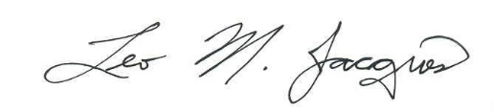
______________________________
IALEIA Elections Chair

